*ALL ABOUT ANDROID*

I

n today’s technology-driven world, Android is a widely recognized operating system that powers numerous smartphones, tablets, and other smart devices. It is present in smartwatches, car infotainment screens, smart TVs, refrigerators, and voice-enabled speakers like Amazon Echo and Google Home. However, despite using Android in our daily lives, do we truly understand how it functions?

Android is developed by a group of companies and developers known as the Open Handset Alliance, though its most widely used version is primarily developed by Google. It was unveiled in November 2007, with the first commercial Android device, the HTC Dream, being launched in September 2008.

Android is the most popular mobile operating system in the world, with over 2.5 billion active devices as of 2023. It is used by a wide range of manufacturers, including Samsung, Google, Xiaomi, and all the brands under the tech giant BBK Electronics (Oppo, Vivo, One Plus, RealMe). Android devices come in a variety of shapes and sizes, from budget-friendly smartphones to high-end devices

# **How Was Android Developed?**

Four Techies Andy Rubin, Rich Miner, Nick Sears, and Chris White founded the company Android Inc. in California in 2003. They were the ones who developed Android. The original goal of Android was to develop software for digital cameras. Later the companies decided to develop an operating system for smartphones.

The Android operating system is based on a layered architecture, with the Linux kernel at the core. The kernel provides basic services such as memory management, process scheduling, and device drivers. The Android framework sits on top of the kernel and provides APIs for developers to build applications. The framework also includes a number of system services, such as the notification system, the power manager, and the location manager.

The Android user interface is based on a graphical user interface (GUI) called Material Design. Material Design is a system created by Google to help teams create high-quality digital experiences for Android, iOS, Flutter, and the web. It provides design for the UI/UX. It includes a set of components that can be used to create visually pleasing user interfaces.

Android apps are written in Java and Kotlin and are packaged in Android packages (APKs). APKs can be installed on Android devices from the Google Play Store or from other sources. Kotlin was announced as the official programming language to develop Android apps in 2019. Android is slowly making a shift from Java to Kotlin.

Android also has security features like sandboxing, asking permissions, encrypting and continuous software updates

# **Android Versions**

Android’s version names have always been something that everyone loves. While other operating systems opt for dull numbers and codes, Android decided to use dessert-themed names. Each new Android release has a desert name in alphabetical order.

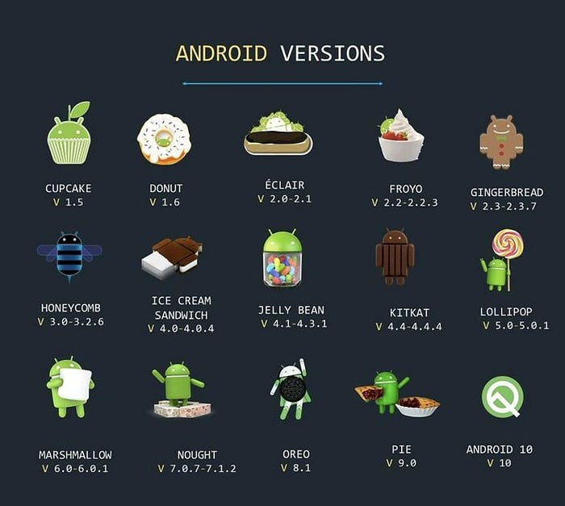

# **Android Development**

Creating an Android app is like crafting digital art, and it all begins with choosing the right programming language. Developers have two main options: Java and Kotlin.

Java: Java has been a staple in Android development for years. Its robustness and faster capabilities make it a reliable choice for crafting apps that run smoothly on a wide range of Android devices.

Kotlin has become a popular language for Android development in recent years. Developed by JetBrains, it is known for being concise, expressive, and enjoyable for developers. The modern syntax and strong type inference have made it a preferred choice for many.

Once the programming language is chosen, developers turn to their playground, the Android Studio Integrated Development Environment (IDE). This powerful tool simplifies the development process and provides a rich set of features like a visual layout editor, emulator and device testing, and a huge number of plugins.

The Android SDK(Software Dev Kit) is a collection of tools, libraries, and resources that provide everything developers need to build Android applications. It includes tools for debugging, performance profiling, and a variety of device emulators.

# **Android in Daily Life**

As of January 2023, Android is used by over 2.5 billion active users worldwide , making it the most popular operating system in the world. People of all ages use Android in various settings, including homes , businesses , schools , and governments .

Android is like our helpful companion in everyday life. It guides us with maps, lets us chat with friends, and entertains us with games and movies. We use Android to check emails, set reminders, and get things done. It’s the reason we can easily find apps for learning, fun, and staying organized. Whether it’s finding the quickest route to work, sending messages to loved ones, or watching our favourite shows, Android is there to make it all easier. Plus, it keeps us connected with the world, providing us with news, weather updates, and endless information at our fingertips.

We not only use Android on our mobiles and tablets but also on devices like:

Smart TVs: Android TV is a version of Android specifically designed for television sets. It’s used in smart TVs from various manufacturers, providing access to apps, streaming services, and more.

Set-Top Boxes: Some set-top boxes run on Android. They offer a wide range of entertainment options and even gaming capabilities.

Wearable Devices: Many smartwatches and fitness trackers, such as those from Samsung and Fossil, run on a specialized version of Android, often called Wear OS.

Automotive Infotainment Systems: Android Auto is a version of Android designed for use in cars. It provides navigation, entertainment, and hands-free communication features when connected to a compatible vehicle.

Home Automation and Smart Speakers: Some smart home devices and smart speakers, like those powered by Google Assistant, have Android at their core to provide voice-activated functionality.

Drones and Robotics: Android can be found in some drones and robots, providing a versatile platform for controlling and programming these devices.

Medical Equipment: In some cases, Android is integrated into medical devices and equipment to provide advanced monitoring and data collection capabilities.

Kitchen Appliances: Certain smart kitchen appliances, like refrigerators, use Android to provide features like internet connectivity and touchscreen controls.

Android is getting better with each update with more features. Current trends are 5g networking, foldable phones and striving to improve the ecosystem.

# **Conclusion**

It's amazing how much Android has influenced the mobile industry! It's brought about so many new ideas, innovations, and made mobile devices more accessible for everyone.

Android has really become a must-have in our daily lives. It's great for keeping us connected, informed, and entertained. With its help, we can get things done faster and have more fun in our free time. It's amazing how much of a difference it can make in our productivity and enjoyment of life.

*Written By:*

*Darshan Ravichandran*

*RA2111027020077*

*B. TECH CSE BDA B*